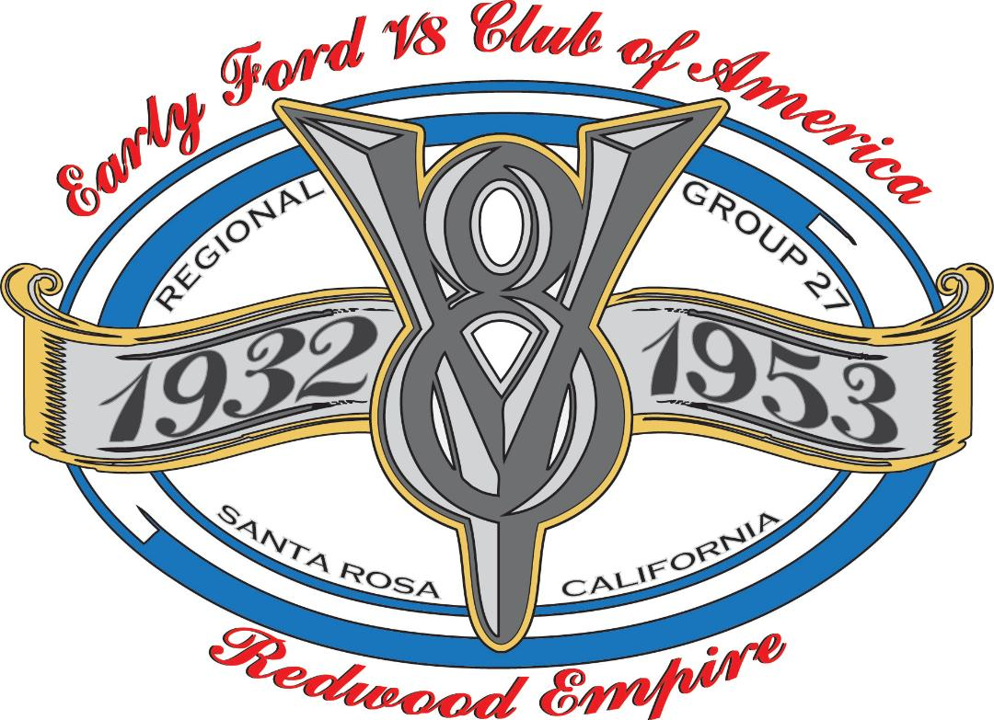
Redwood Empire Regional Group #27
P.O. Box 3302
Santa Rosa, California 95402

March, 2021
Happy March.

This is the month the Leprechaun is going to help us get Lucky and get on the path to getting through the pandemic. Dave and I have received our first Covid injection and scheduled to get our second shot in three weeks. Hopefully most of our members have received the shots or on a list to get them soon.

Our new club member, Steve Vining, has been working on our Regional Clubs website and I encourage all of you to check it out. This is very exciting to have it updated with current information for our members and people wanting to know more about us. Thank you Steve for stepping up and helping us. Go to RedwoodV8.net and check it out.

On the home front, look at what came home from the paint shop. Dave is super excited with his Falcon coming home and is starting the process of getting the interior complete and getting all the new chrome and fun parts attached. Before you know it Dave and I will be on the road reliving our High School Dating Days.

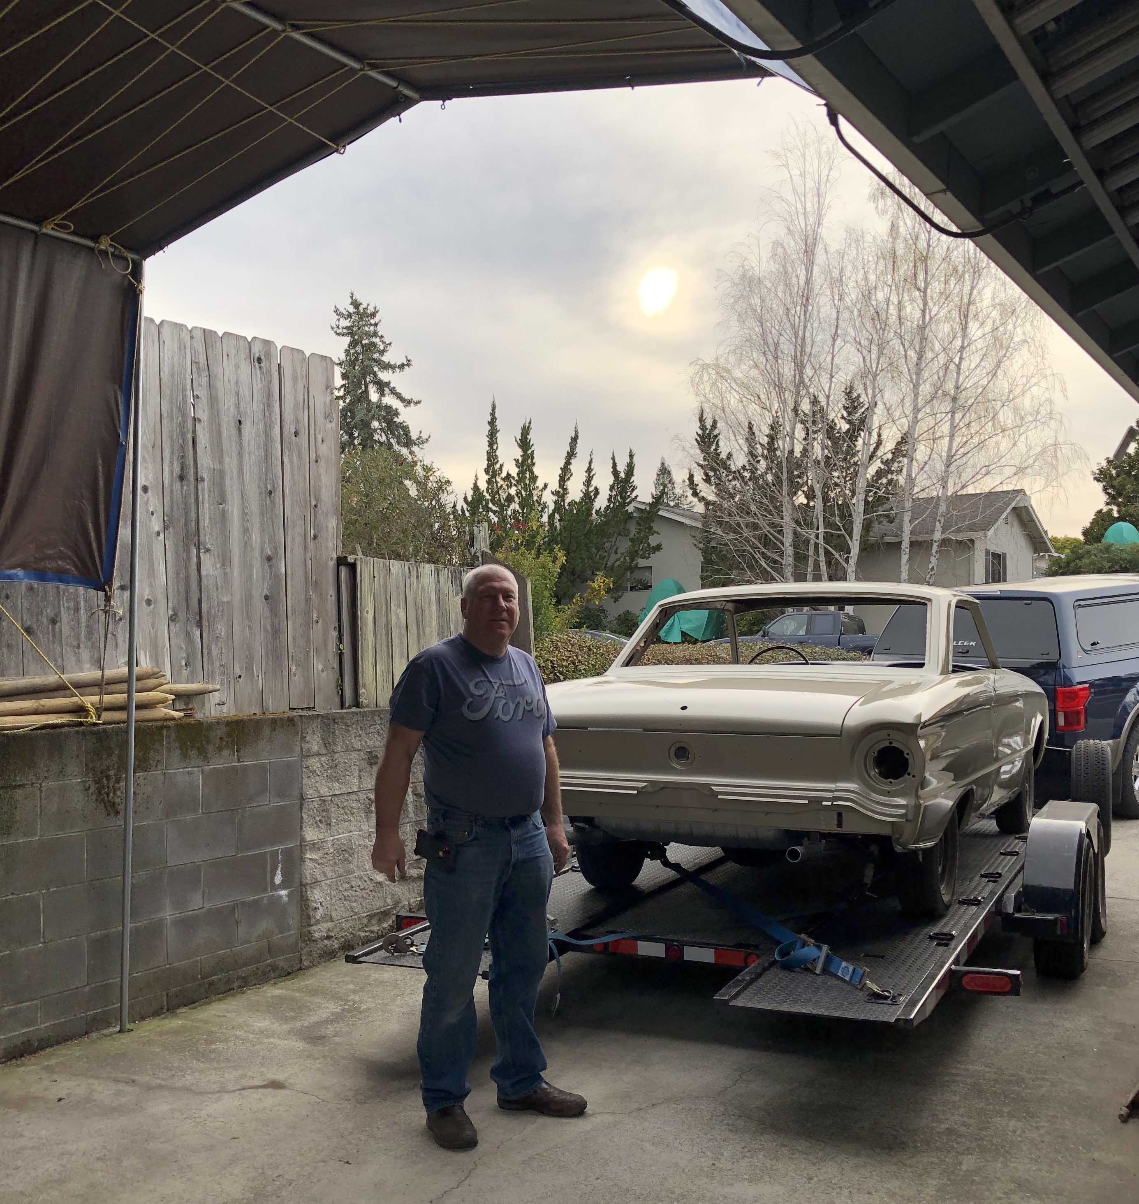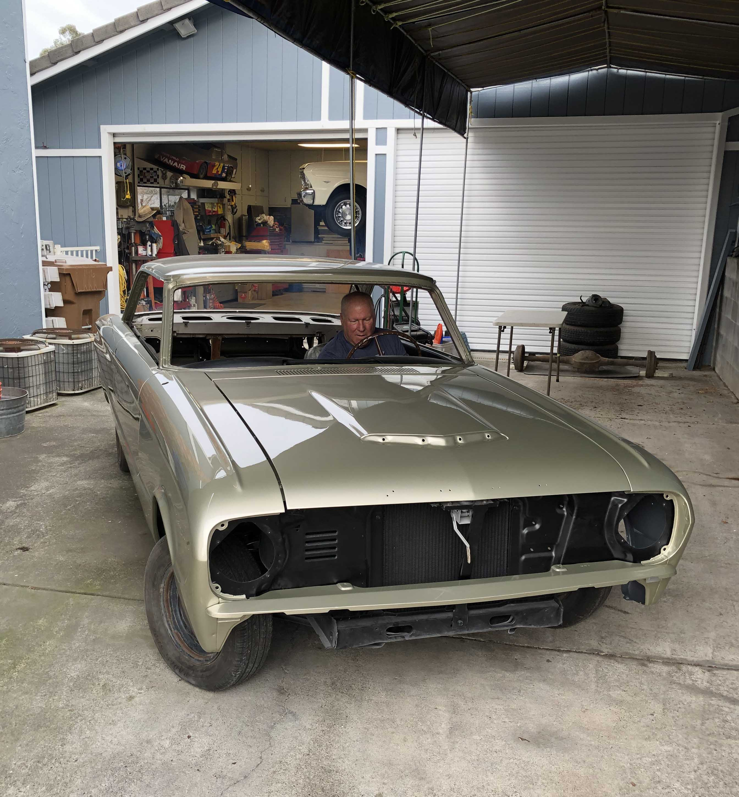

The Burney Car Show is happening this year on May 29th. Tom Johnston will be traveling up to Burney on Thursday the 27th. This is not a club sponsored event and you will need to get together with your friends and travel with them for the weekend. Please double check your reservation if you are attending or make sure you cancel your reservation if you decide not to go. There is a possible drive tour on Friday and no Banquet planned on Saturday evening. Tom says the restaurants are open and ready to serve us. If you are planning on attending, please let Tom know. Give him a call at 707-255-1230. Hopefully our Club will be able to sponsor a tour or event soon. If you have any ideas for later in the fall, let us know.

Dave Peterson has been here recently working with my Dave on projects and asked me to find out who baked
Rhubarb Strawberry pies for the Swap Meet. I have no idea. Dave needs this information. If you remember,
Let me know or you can contact Dave Peterson directly. Thank you.

Have a great month and join us for our Zoom Club Meeting Next Tuesday the 9th at 7:00.
Our Zoom code is 283 760 6253 with a passcode of kx4Xqy or 098852

I will send an invitation on Sunday. Hope to see you. - Carol

Happy Birthday

Mar 05 Dona Godwin
Mar 07 Jane Castle
Mar 08 Michael Knips
Mar 13 Dan Pallo
Mar 13 Cindy Vining
Mar 20 Bill Burns
Mar 24 Louis Cantarutti
Mar 25 Kathy Derickson
Mar 29 Brian Clary
Mar 29 John Girman
Mar 29 Wilma Lenz
Mar 30 Chuck Paul
Mar 30 John Thompson
Mar 31 Jeanne Abate

Minutes of General Meeting: Tuesday February 9, 2021
The Zoom Meeting was called to order at 7:05 pm by our President Carol Rasmussen.
The Minutes of Meeting: The minutes of last month’s meeting were approved as submitted,.
Members in attendance tonight: 31
Treasurer’s Report: Treasurer Dennis Ripple presented the monthly treasurer’s report.
New Members and Guests: Steve & Cindy Vining are new members in attendance; they have a 1909 Ford and a 1926 Ford Roadster Pickup.
Birthdays: Dave Wyss was tonight’s winner, he was given his choice of a V-8 necklace or a V-8 grill badge as his gift and chose the necklace, everyone sang Happy Birthday to Dave & Donna Fredrick.
Business: The Board of Directors decided that the club will not charge dues this year as there are no meetings at present, therefore no Pizza nights and not very many expenses. Everyone who has already sent in their dues will be credited for next year’s dues.
New member Steve Vining will be our new Webmaster, updating and bringing our website current. t is going well so far, but much more to do, Thanks Steve for stepping in.
Carol announced that the long awaited 1940 Ford book has arrived. It is 388 pages of wonderful information.
The Portland Swap Meet has been canceled this year.
Tours and Events: Tom Johnston reported that there will be a Car Show in Burney at the Pit river Casino on Saturday May 29th, and he is planning on going, members who are interested in going should check to see if they have a registration at the Burney hotel, and members that are not going this year should check to see if their registration was carried over from last year and cancel if they are not going.
Sunshine Lady: Jack Helmke had caught the Corona Virus last February and was in the hospital as it was pretty severe; he is home now but still recovering. Dave Peterson is doing well after his back surgery. Dave Wyss gave updates on various members
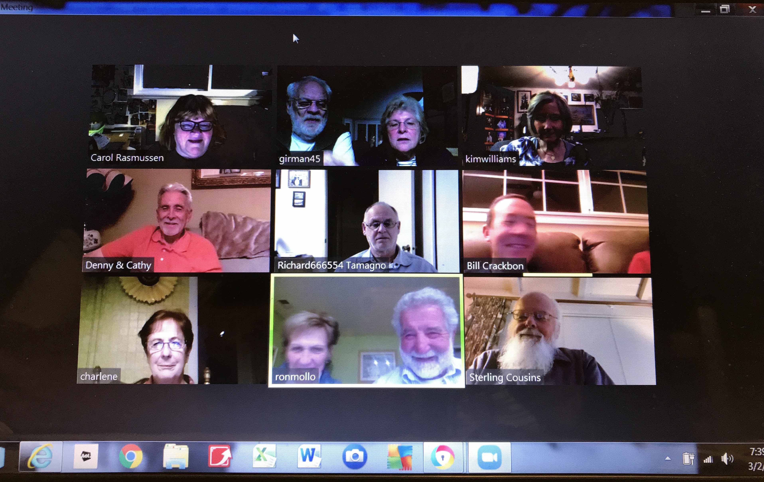
Hard Luck: None reported
Tech tips: None reported
Cars and Parts for Sale: 40 Ford 2 Door Sedan for sale in Novato. 20 - 25K
Club Cars Driven to the Meeting: Everyone had their car with them tonight
Membership Attendance Drawing: Darrel Billings was the winner tonight but was not present.
Carol’s Carload of Fun: Carol had a great Valentine’s Day game for all the members, but we had to provide our own candy.
Scholarship Raffle: None tonight
The meeting was adjourned around 7:45. ……..
Minutes submitted by Steve McClain, Club Secretary. Your V-8 Board hard at work.

